
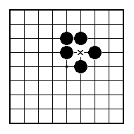
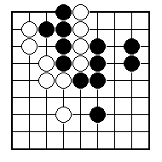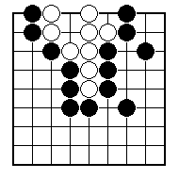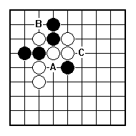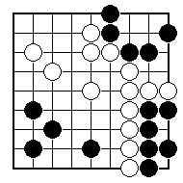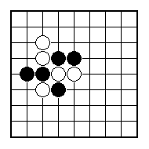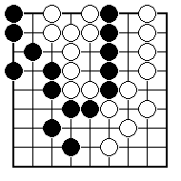
How can white save the weak white group?

How can white save the weak white group?
.

Where is White weak? Should Black attack with A, B or C?

Which is the weak group Black needs to defend?

Find a play that helps White’s weakest stone or stones and attacks Black.

Black to play. Which of the two weak groups will die first?

NAME:
BRITISH GO ASSOCIATION CERTIFICATE LEVEL 2 - SHEET 9

STRONG AND WEAK

